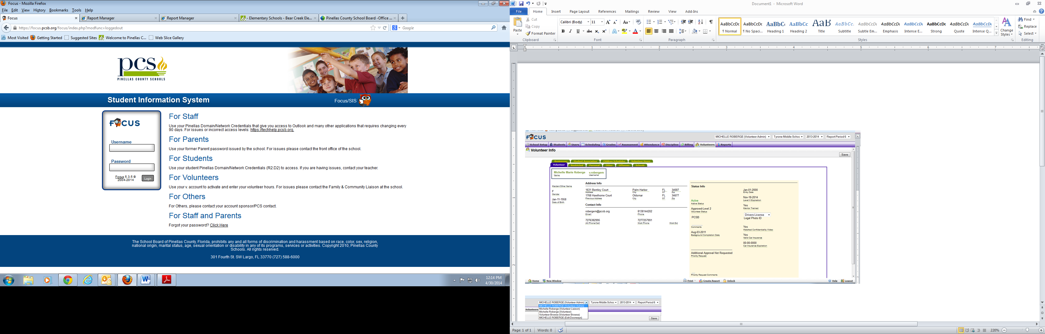Login page for Administrators, School Liaison or Volunteers

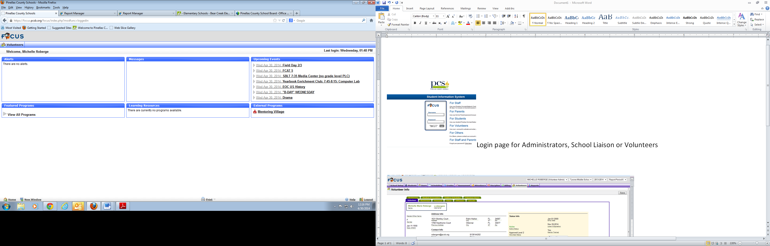

Volunteer Page – Message Board, Update of profile, Calendar, Programs and what other features you offer

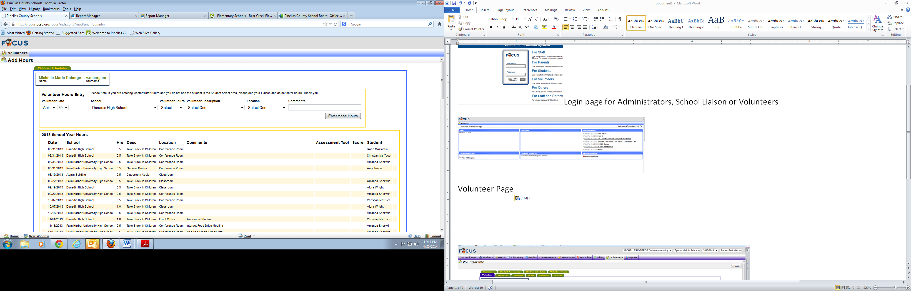

Adding volunteer hour’s page

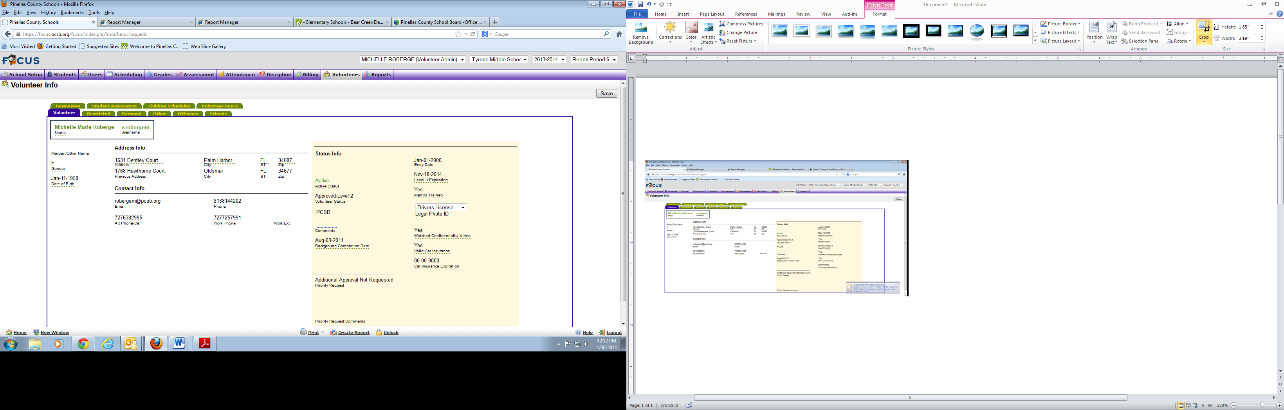

**Highlights of what the Admin and School Liaison can see. The Volunteer does not have access to this information in our system**

**Administrators Page** – Schools would not have access to Restricted or Offense Tab - Snap shot of Volunteer profile

**Restricted Tab** – Social Security

**Personal Tab** is Ethnicity, Legal ID Info, State, ID Number and ID Expiration, Emergency Contact, County of Origin, Box for Shield Identity

**Other Tab –** Employee Status, Student Status Volunteer Job Interest, Tutor Type/Trained Date, Mentor Type Description, Training Dates Volunteer Experience/Talent, Car Insurance/Expiration Date/ Level 2 Expiration Date

**Offense Tab** – Number of Year Ineligible, Offense Type, Disposition, Date of Offense Filed, Location

**School Tab -** Schools volunteer is associated to

**Student Association** – What students the mentor or tutors are associated to. Type of program Mentor/Tutor. Date of Placement, Follow Student, name of student and grade.

**Volunteer Hours Tab –** Either the Administrator, school liaison or volunteer can enter hours. Hours need to include Date, School, Hrs, Description of program, location, comments, Assessment Tool, Score Student

This is managed by 1st Semester and 2nd Semester

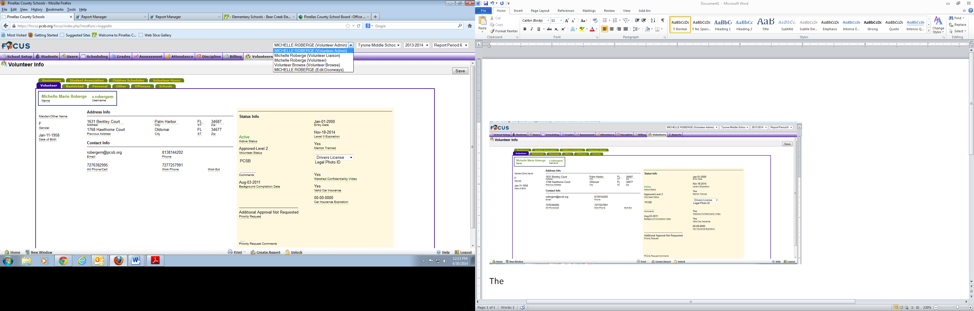

These are the levels – Administrators See and do everything

Approximately 5 Administrators

140 - Liaisons only see their volunteer and only see a sub-set of data

Volunteer Browse allows the liaison to look at the whole volunteer data base and associate that volunteer to their school.

20, 000 Active volunteers

70,000 In Active Volunteers

To date 600,000 Volunteer hours